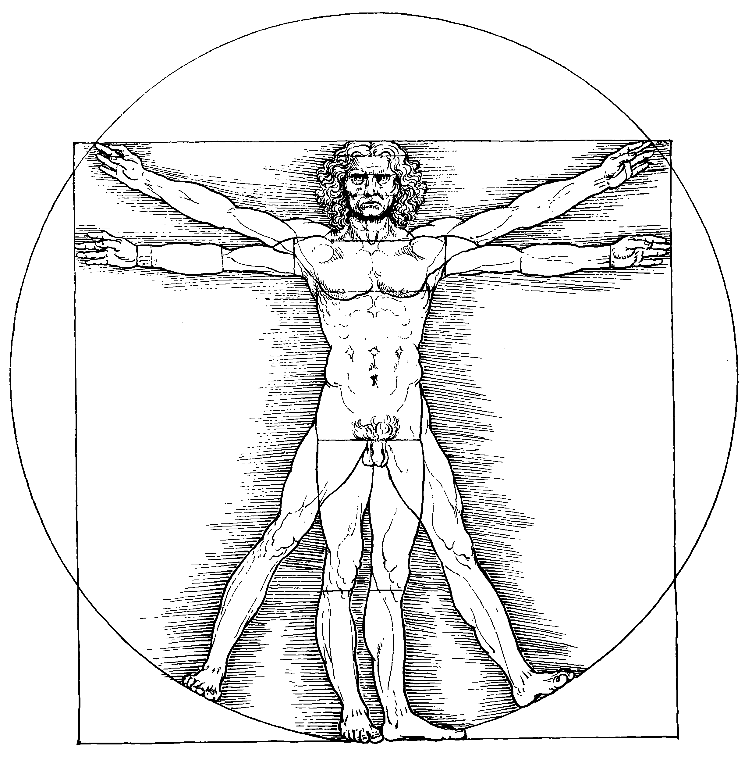

The Body in History | Interdisciplinary Postgraduate Career Researcher and Early Career Researcher Conference
Monday, 6 July 2026
Schwarzman Centre for the Humanities, University of Oxford

Academic study is often concerned with the mind, with ideas, reason, and fact which are implicitly set against the messy, complicated realities of human embodiment. However, recent decades have seen a turn towards the body across the humanities and social sciences, a wide-ranging and dynamic topic. Alongside this ‘somatic turn’ in academia, contemporary culture displays something of an obsession with the body, its appearance, performance, and management. Moreover, even when our research does not directly touch on the body, we all have bodies, and our engagements with the university and archive as well as broader society are informed by our different experiences of embodiment.
The Body in History Network is a research network based at Oxford. We bring together researchers across disciplines interested in the history, representation, and experience of the human body and its environments. The group provides a space to unite the disparate range of body research at Oxford, offering a unique opportunity to cross disciplinary divides, network, and share insights. Please email bihn@history.ox.ac.uk to join our mailing list.
The Body in History Conference is generously funded by The Oxford Research Centre in the Humanities Critical Thinking Communities Programme (TORCH), The TORCH Medical Humanities Hub, and Magdalen College, Oxford.

https://www.torch.ox.ac.uk/the-body-in-history-network
Please direct any questions to bihn@history.ox.ac.uk
Please follow us on Bluesky @bodyinhistoryox.bsky.social. Feel free to share about the conference online and tag us in any posts!

 | Schedule
 | Schwarzman Centre for the Humanities, University of Oxford
 | Date | 6/7/2026 | 6/7/2026
 | Time | Learning Centre | Seminar Room 63
 | 8:30 - 9:00 | Registration  Collect conference pack and name badge from registration desk opposite the Learning Centre, at the North Entrance.  The Cafe and Coffee Bar will be open from 8:00
 | 9:00 - 9:10 | Welcome Remarks  Helena C. Aeberli on behalf of the Body in History Team  In the Learning Centre
 | 9:10 - 10:25 | Panel 1: The Institutionalised Body  'Between Instrument and Sabotage: The Captive Body in German Prisoner of War Camps' (Sarah J Bremer, University of Wolverhamptom)  'The Standard of Living of Female Offenders in Durham, Newcastle and County of York 1853-1888' (Kerri Armstrong, Northumbria University)  '‘We endeavour in every possible way to restore them physically’: The Metropolitan Police Home and the care of sexually abused girls in early 20th century London' (Seonaid Anthoney, Independent Researcher) | Panel 2: The Body in Performance  'Wigs, Headpieces, Makeup: Stepping out of Ethnicity, Going Beyond Human in Ballet' (Linda Kvitkina, University of Oxford)  'Barbara T. Smith’s I Am Abandoned (1976): Embodiment in the Imbrication of Art and Artificial Intelligence'' (Anna Mayer, The Courtauld)  'Body Art Between Action and Performance: Reconsidering Embodiment at Moltkerei Werkstatt' (Anja Segmuller, University of Oxford)
 | 10:30 - 11:45 | Panel 3: Representing the Body  '“Paris as a Gateway to Africa”: Négritude, Afro-Diasporic Communities Abroad, and Loïs Mailou Jones’s Modern Black Portraiture' (Devon Rosenberger, University of Oxford)  'New Bodies, New Culture: Bodily Integration, Revolutionary Will, and the Politics of the Somatic in Maoist Propaganda Posters' (Qiyi Huang, New School for Social Research)  'Display as Discipline: The Representation of the Female Body in Early Modern Anatomical Fugitive Sheets' (Hanne Berendse, University of Innsbruck and The Warburg Institute) | Panel 4: Writing Bodies and Writing the Body  'Death by the book: The fin-de-siècle livre de luxe as body, female flesh and toxic poisoner' (Elisian Ralli, University of Oxford)  'Vegetal Femininity: Plant, Body, and Resistance in Women's Fiction' (Yang Zhang, Jinling Institute of Technology)  'Commonplacing Meets the Body' (Finn Manders, UCL and Wellcome Collection)
 | 11:45 - 12:00 | Break  Complimentary tea and coffee and refreshments can be collected from Room 00.079A.
 | 12:00 - 1:00 | Keynote Lecture: Curating the Body  In Seminar Room 63  Curators from the Wellcome Collection's 'Expecting: Birth, Belief, and Protection' exhibition
 | 1:00 - 2:00 | Lunch  Complimentary lunch and tea and coffee can be collected from Room 00.079A and eaten in the Great Hall, Cafe, or outside spaces.
 | 2:00 - 3:45 | Panel 5: Medicine, Health, and Disability  'Short Tempers: Angry Women in Early Modern Medicine' (Hannah Cotteril, Royal Holloway University)  '“Swelled legs, domestic, healthy”: meanings of health and the problem of recovering enslaved experiences from the nineteenth-century colonial Guyanese archive' (Toyin Akinkunmi, Independent Researcher)  'Visible and Invisible Bodies: Disability, Medicalisation, and the Negotiation of Self in the Eighteenth-Century Country House' (Ruby Rutter, University of Manchester)  'A monster of ‘his body’? Fathers in British early modern ‘monstrous’ birth narratives' (Ella Sheddick, UCL and Wellcome Collection) | Panel 6: The Reproductive Body  'Tu Enfanteras Dans La Joie: Depictions and Discussions of Pregnancy in French Communist Women’s Magazines, 1945-1955’ (Eli Jeannin, QMUL)  'Sex education, ‘family planning’ and body knowledge for young women in late twentieth century Ireland' (Maire Hussey, Trinity College Dublin)  '"For Greece, Contraception Means Abortion": Reproductive Bodies, Institutional Silence, and Feminist Production in Post-Junta Athens (1975-1986)' (Angeliki Kokkali, University of Glasgow)  'Bodies and Spirits: Reproduction and Spiritualism in the Antebellum United States' (Nienke Groskamp, University of Cambridge)
 | 3:45 - 4:40 | Panel 7: Diet and Digestion  'The restrictive effects of Georgian (over)indulgence' (Ailsa Maxwell, University of Oxford)  'Eating for vitality: Digestion, self-nurturing, and the making of the hygienic body in late Qing China' (Ge Yang, Durham University) | Panel 8: Bodies Politic  'Running Bodies, Remembered Nations: Nostalgia, Embodiment, and Sporting Identity in Modern Japan' (Ziwei (Jade) Xuan, University of Edinburgh)  'Le Cartel des Quatre: Theatre, Politics, and Actor Training in Interwar Paris' (Jonathan McAllister, University of Cambridge)
 | 4:40 - 5:00 | Closing Remarks and Discussion | Closing Remarks and Discussion
 | 5:00 | Conference Drinks  Details to follow

Abstracts
Panel 1: The Institutionalised Body
'Between Instrument and Sabotage: The Captive Body in German Prisoner of War Camps' (Sarah J Bremer, University of Wolverhamptom)
This paper examines the First World War prisoner of war camp as a site in which the captive body was both economically instrumentalised and contingently contested. German war-economy policy reconceived prisoners as labour resources, calibrating rations, medical treatment, and exchange eligibility to preserve productive capacity amid domestic scarcity. Archival evidence demonstrates how bodily value was assessed through output: labour-capable men were retained, labour-injured bodies excluded from exchange, and medical intervention frequently limited to restoring work fitness. The captive body thus functioned as labour capital within a system of national self-preservation.
Yet this instrumental logic did not eliminate embodied agency. Testimony from British prisoners suggests that in certain coercive contexts — particularly punitive labour detachments — bodily breakdown could alter a prisoner’s position within the camp regime. Self-harm and collapse were not uniformly strategic, nor uniformly pathological; rather, they emerged within conditions in which mobility, protest, and refusal were structurally constrained. Under such pressures, the body could become a fraught site through which circumstances shifted, even at severe personal cost.
By positioning the captive body between instrument and sabotage, this paper reframes captivity as a struggle over embodied value, highlighting the unstable boundary between vulnerability and constrained resistance in wartime imprisonment.
'The Standard of Living of Female Offenders in Durham, Newcastle and County of York 1853-1888' (Kerri Armstrong, Northumbria University)
This paper explores the economic, social and environment conditions of two hundred and thirteen sampled women that were convicted by the Sessions and Assizes Courts of Durham, Newcastle and the County of York between, 1853-1888, by providing a regional case study of the quality of living of the women of the working classes in the northeast England. The primary resource used for this paper is parole records taken from the UK Licence of Parole of Female Convicts, 1853-1871, 1883-1887, held at the National Archives under PCOM4 and digitised on ancestry.com. Drawing on height and weight data recorded in each woman’s parole file, this paper examines the relationship between body measurements and living standards, documenting the bodies that bore witness to the harsh realities of life. Anthropometric research has instigated the use of different methods for measuring human quality of life other than economic development, such as height, weight or BMI, demonstrating their importance as an indicator of an individual’s socio – economic environment. Living environment is intrinsic to health, but data about women’s bodies can be hard to find. This paper contributes not only to the field of female standard of living by presenting new evidence from a previously unexamined source, but also to the field of female crime by considering each offender as a whole person, and not just a snapshot of their criminality.
'‘We endeavour in every possible way to restore them physically’: The Metropolitan Police Home and the care of sexually abused girls in early 20th century London' (Seonaid Anthoney, Independent Researcher)
In 1911 the Metropolitan Police Home for Women and Children was founded in Lambeth toaccommodate young female victims of sexual violence whilst they provided witness testimony in court. In sexual abuse cases, the body was the site of the crime, therefore it was subjected to invasive medical examinations by doctors, scrutiny in the court and cleansing at the Police Home. Despite a growing body of literature on children’s residential homes and sexual abuse in the nineteenth and twentieth century, scholars have largely neglected the Police Home. This study examines sources previously largely unexamined: the Police Home Annual Reports from 1911-1933 and the Mary Leaf Fund Annual Reports from 1914-1933. The Police Home provides new insight into the treatment of child sexual abuse victims in early twentieth century London and how the body was viewed as an important aspect of rescue work. Building upon Julia Laite’s initial work on the Police Home and the work of Louise Jackson, Laura Lamasneimi and Victoria Bates on child sexual abuse in Victorian and Edwardian England this paper seeks to understand how the body was treated in the care of sexually abused girls in London through a case study of the Police Home.

Panel 2: The Body in Performance
'Wigs, Headpieces, Makeup: Stepping out of Ethnicity, Going Beyond Human in Ballet' (Linda Kvitkina, University of Oxford)
The backstage of the State Academic Opera and Ballet Theatre in Kazakhstan is a space in-between, where a ballet practitioner becomes a performer with the help of several devices, one of them is costume, the other is hair and makeup. For many ballets produced in the Soviet Union, ethnic identity (and the recognition of such by viewers) was fundamental to the plot, and many ballets offered non-human characters, which meant the dancers had to adjust their movement, making it recognizably animalistic yet remaining within the boundaries of ballet, and change their human features. In this paper, I seek to answer the question of how hair and makeup assisted the transformation of a ballet practitioner into a performer, and, more importantly, how the temporary transformation of appearance helped dancers embody a different ethnic identity, or go beyond the human. Through the archival documents from as early as 1934, I will trace how the hair department mirrored conceptions of race and ethnicity in the Soviet Union, and how dancers engaged with makeup – applying it and taking it off, as well as going on stage barefaced, and why it was deemed unacceptable by the Theatre administration.
'Barbara T. Smith’s I Am Abandoned (1976): Embodiment in the Imbrication of Art and Artificial Intelligence'' (Anna Mayer, The Courtauld)
This paper centres on the feminist performance artist Barbara T. Smith’s pioneering and prescient I Am Abandoned (1976): the first performance to utilise early artificial intelligence. The work set a conversation between two chatbots against a projection of Francisco Goya’s The Naked Maja (1795-1800) over the reclining body of a female model. Through this literal and conceptual confrontation, I Am Abandoned staged human embodiment as an interference to artificial intelligence.
In the fiftieth anniversary year of I Am Abandoned, this paper explores how the performance employed the body to draw attention to artificial intelligence’s embodied, affective, and ethical stakes. In this sense, by prompting us to think about the ways that bodies figure in supposedly disembodied systems, the performance foregrounded how networks of machinic cognition are distributed along embodied and therefore gendered, classed, and raced lines. Finally, this paper explores how I Am Abandoned used this confrontation between embodiment and artificial intelligence to anticipate contemporary critiques concerning the ways that labour underpins the ongoing development and maintenance of artificial intelligence, and how the global distribution of this labour reflects and reinforces existing inequalities.
'Body Art Between Action and Performance: Reconsidering Embodiment at Moltkerei Werkstatt' (Anja Segmuller, University of Oxford)
Body art emerged in the late 1960s and 1970s as a radical artistic practice that placed the artist’s body at the centre of aesthetic experimentation. Closely related to traditions of action art and performance art, these practices challenged conventional distinctions between artwork, artist, and audience while foregrounding the body as both medium and site of political and social inscription. Early body art is frequently associated with figures such as Joseph Beuys and the Viennese Actionists, whose provocative performances emphasised the body’s vulnerability, endurance, and symbolic power.
This paper examines the development of body art through a socio-cultural history of the alternative art space Moltkerei Werkstatt in Cologne, a key venue for experimental live art during the 1970s, 1980s, and 1990s. Drawing on previously unexplored archival sources, it traces how artists including Ulrike Rosenbach, Marina Abramović and Ulay, Tomas Ruller, as well as the East German collective Autoperforationsartisten, used the space to stage performances that reconfigured the body as a site of experimentation, gender politics, and transnational artistic exchange.
By reconstructing the performance programme of Moltkerei Werkstatt, the paper argues that alternative art spaces played a crucial role in shaping the development of body art beyond the canonical narratives centred on individual artists or national movements. Examining the embodied encounters between performers and audiences within this institutional setting offers new insight into how body art circulated, evolved, and acquired meaning in late twentieth-century Europe.

Panel 3: Representing the Body
'“Paris as a Gateway to Africa”: Négritude, Afro-Diasporic Communities Abroad, and Loïs Mailou Jones’s Modern Black Portraiture' (Devon Rosenberger, University of Oxford)
In October 1937, a young Loïs Mailou Jones arrived in Paris to undertake a year of artistic study while on sabbatical from her position as a professor of art at Howard University in Washington, DC. Jones arrived in Paris at the rise of Négritude, a literary, cultural, and intellectual movement rooted in developing a global ‘Black Consciousness’ in an effort to promote Africa and its diaspora. In this paper, I consider Jones’s interaction with Africa and its diaspora through her movements in Paris, arguing that the rise of new anti-colonial and anti-racist philosophies influenced her engagement with French artistic traditions. In her portraits of Afro-diasporic peoples in Paris, Jones played with the notion of hybridity as she herself continued to explore her own personal diasporic identity. In these modern portraits of Black sitters, she departed from traditional depictions of Black subjects circulated in France. Rather than employing ethnographic, Orientalist, or phrenological visual tropes meant to assert difference between the Black subject and white viewer, Jones presented viewers with an image of the modern Afro-diasporic subject, taking part in the global effort to reframeBlackness in a positive light.
'New Bodies, New Culture: Bodily Integration, Revolutionary Will, and the Politics of the Somatic in Maoist Propaganda Posters' (Qiyi Huang, New School for Social Research)
What does a revolutionary body look like? Maoist propaganda posters of the People's Republic offer a distinctive answer — one that pushes beyond the socialist aesthetic tradition toward a more radical experiment: not the aestheticization of politics, wherein the body becomes a mere spectacle engineered to dissolve mobilisation into aesthetic gratification, but something closer to what Walter Benjamin called the politicization of art.
Rather than a static object of contemplation, the body in Maoist visual culture is always a body-in-situation: labouring, moving, acting. It carries not only physical force but willpower and revolutionary spirit — a fusion of the material and the volitional that reflects the voluntarist strand within Maoist thought. This bodily integration — the de-differentiation of gender through class, all bodies labouring, equal in force and contribution — was not conceived as suppression but as empowerment. Ideology does not interpellate abstract subjects; it interpellates bodies. The underlying logic holds that new bodies will organically generate new culture, which will realise the revolution.
It is this conviction — that aesthetic and bodily transformation are themselves political transformation — that makes the labouring, willing, integrated body of Maoist visual culture not merely a historical image, but a site where politics was believed to be made.
'Display as Discipline: The Representation of the Female Body in Early Modern Anatomical Fugitive Sheets' (Hanne Berendse, University of Innsbruck and The Warburg Institute)
Across early modern Europe, a primary concern was keeping women, and by extension their bodies, in check. From medical discourse to visual culture, female physiology was mobilised to justify women’s exclusion from intellectual, political, and public life to prevent social disorder. This paper examines the anatomical fugitive sheet – a mass-printed broadsheet meant for interactive use by a non-specialist male audience, featuring layered paper flaps that revealed successive strata of the human body – as a case study. Accompanied by explanatory texts, the sheets presented the male body as the ‘human’ body, while the female body was framed as derivative, passive, and defined primarily through reproduction. The interaction of text and image positioned the male body as normative and authoritative, with the female body displayed as an object of epistemic – and erotic – consumption. By analysing the sheets at the intersection of iconography, medical history, and gender studies, this paper argues that anatomical fugitive sheets, under the pretense of ‘know[ing] thyself’, served as instruments to discipline female bodies and reinforce gendered hierarchies. Thereby, the sheets illustrate how in the early modern period, too, mass media was deployed to regulate women’s bodies and stabilise social order

Panel 4: Writing Bodies and Writing the Body
'Death by the book: The fin-de-siècle livre de luxe as body, female flesh and toxic poisoner' (Elisian Ralli, University of Oxford)
‘Your book has literally made me ill’, wrote artist Jean-François Raffaëlli to J.-K. Huysmans regarding his novel À Rebours (1884). Reprinted in a luxury edition by the Cent Bibliophiles society in 1903, it centres on an isolated bibliophile who commissions bespoke editions and lives through tactile rituals of smelling, handling, and contemplating books. This fictional collector became a model for fin-de-siècle bibliophile societies: elite circles of collectors who artistically edited and hand-printed their own limited-edition livres de luxe. Drawing on such editions, this paper traces the bodily relationship that developed between book and bibliophile in this period.
In these exclusively male circles, books are feminised as their materiality (leather binding, illustrations, paper) stages a fantasy of possession and tactile interaction. Anthropomorphised books replace women and become mistresses, erotically involved with their collector. Yet, the book soon turns poisonous in the guise of an alluring but deadly femme fatale, central to the Decadent imagination. Rooted in nineteenth-century ‘arsenophobia’ , the fear of contamination through touch looms over bibliophilia; medicalised language frames book-collecting as intoxication or pathology, in keeping with the period’s fixation on the physical symptoms of neurosis —the disease of the century. The livre de luxe ultimately emerges as both female flesh and mirror: a body onto which the collector projects his self-image, even as his body risks dissolving into the library that reflects it.
'Vegetal Femininity: Plant, Body, and Resistance in Women's Fiction' (Yang Zhang, Jinling Institute of Technology)
This paper proposes "vegetal femininity" as a critical concept for reading a recurring figure in women's writing: the female body that becomes, desires, or is forced into plant-life. Drawing on Han Kang's The Vegetarian and The Fruit of My Woman, Anne Richter's The Sleep of Plants, and Pat Murphy's His Vegetable Wife, and engaging with Michael Marder's plant-thinking, corporeal feminism, and ecofeminist theory, the paper traces three registers in which vegetalization is figured: as negation, a radical and embodied refusal of patriarchal and social order (Han Kang); as return, an affirmative longing for a primal, interconnected state of being prior to social inscription (Richter); and as a condition imposed by male will, endured through abuse, and finally reversed in an act of lethal reclamation (Murphy). Their shared position as women writers is itself constitutive of the argument: across Korean, European, and Anglophone traditions, these authors collectively engage the vegetal female figure as a site of rewriting — reclaiming a symbol that patriarchal culture has long used to render women passive, rootless, or ornamental — and it is this transnational act of rewriting that the paper ultimately seeks to theorize.
'Commonplacing Meets the Body' (Finn Manders, UCL and Wellcome Collection)
In the library, chapel, and the ‘great and little parlours’ of Catledge Hall, Cambridgeshire, the domestic chaplain Nathaniel Dalton compiled his commonplace book. Beginning in January 1668/9, Dalton blended body-mind processes of reading, writing and transcribing to create a large, alphabetically-headed folio volume. This process of compilation was one of bodily ‘doing’: of the hand across the page, between heavy books and reading devices, and up and down the halls and stairs of Catledge Hall.
This paper uses Dalton’s manuscript commonplace book as a case study to explore the physical and bodily processes of commonplacing as ‘making and doing’. It draws from the third chapter of my thesis which, as a whole, argues for commonplacing to be considered alongside care and healing as a form of ‘body-work’ (Fissell, 2008). Here, I specifically attend to Dalton to suggest that ‘the body’ is a crucial lens through which historians can begin to move beyond the epistemic concerns which continues to dominate commonplacing scholarship (e.g. Vine, 2019; Cevolini, 2016). Speaking to recent work in the embodied histories of reading and writing (e.g. Hannan, 2016; Grafton, 2020), this paper offers a refreshing take and new case study for commonplacing as an embodied, environmentally-situated act.

Panel 5: Medicine, Health, and Disability
'Short Tempers: Angry Women in Early Modern Medicine' (Hannah Cotteril, Royal Holloway University)
In 1615, Helkiah Crooke addressed a ‘notable controversie’ in his theory that women have colder humoral bodies than men. This controversy was female anger. Crooke addresses hiscontemporaries’ perception that women are often angrier than men, which some believe to be a sign of a hotter humoral temperament, by distinguishing masculine from feminine anger. Women’s anger is apparently temporally different: soon incited, but also soon appeased. It is also caused by trivial, petty reasons as opposed to men’s supposedly more honourable anger. Crooke differs female anger from the natural hot temper of men by classifying female anger as a ‘disease of a weak mind which cannot moderate itself’, stemming from a colder body which is more susceptible to changes. According to writers like Crooke, women’s anger is always untimely, naturally unnatural and lacking self-control.
My paper explores how anger was central to a construction of a gender binary in early modern medicine but also that this binary was inherently unstable and full of internal contradictions. I explore how women’s anger was constructed through a collection of linguistic oppositions, which sheds light on the significance of emotional behaviour to early modern gender construction.
'“Swelled legs, domestic, healthy”: meanings of health and the problem of recovering enslaved experiences from the nineteenth-century colonial Guyanese archive' (Toyin Akinkunmi, Independent Researcher)
Enslaved people routinely experienced illness and injury – nevertheless, recovering evidence of enslaved people’s own meanings and experiences of their bodies is difficult. Scholars working within the growing body of literature on slavery’s afterlives (the continuation of the slave condition post-emancipation) can argue that full recovery of enslaved life is impossible, because the archive itself is a collection of their deaths.
This paper explores the problem of recovery by interrogating a relatively “open” archive. Unusually for an Anglophone Caribbean colony, the Guyanese colonial archive retains the enslaved’s third- and sometimes first-person legal testimony. I analyse complaints enslaved people made to the colonial Protector of Slaves between 1819 and 1834, alongside missionary diaries and travel writings.
This paper finds that plantation and colonial officials often used enslaved people’s testimony of ill health to justify denial of healthcare. These officials typically asserted that the enslaved person was completely healthy, even when officials recorded evidence of ill health. The implicit assertion was that the enslaved body’s natural condition was ruin. This veil of bodily ruin means that enslaved people can appear in the archive in a superposition of being simultaneously completely healthy and completely unhealthy, revealing a new dimension to the problem of recovery.
'Visible and Invisible Bodies: Disability, Medicalisation, and the Negotiation of Self in the Eighteenth-Century Country House' (Ruby Rutter, University of Manchester)
This paper examines how elite women negotiated the social visibility of their bodies in the eighteenth-century country house through the contrasting experiences of Charlotte Winn (1738–1798) and Cecilia Strickland (1741–1814). It argues that illness and disability were not only physiological conditions, but sites of tension between bodily visibility, social
legibility, and personal control, shaped by women’s positions within the life cycle.
For Charlotte—an unmarried second daughter—proposed medical interventions threatened to render her condition permanently visible, transforming her body into a spectacle that risked undermining her femininity, sociability, and marital prospects. Her refusal of treatment reveals the extent to which the legibility of the female body was bound to expectations of beauty, propriety, and future potential. By contrast, Cecilia, as a wife and mother who had secured her dynastic role, navigated paralysis from a markedly different position. Rather than resisting her condition, she adapted to it, incorporating an altered chair into her daily life and articulating a sense of comfort and stability within her domestic environment. Her experience complicates narratives of disability as purely disruptive, instead highlighting its potential to generate alternative forms of agency grounded in material and spatial adaptation.
By placing these women in dialogue, this paper reframes the eighteenth-century body as contingent and socially mediated, shaped as much by life stage and status as by physical condition.
'A monster of ‘his body’? Fathers in British early modern ‘monstrous’ birth narratives' (Ella Sheddick, UCL and Wellcome Collection)
Early modern monstrous births have been intensely examined by historians; monstrous bodies have been understood as portents, jokes or objects of scientific enquiry. Similarly, the maternal bodies that produced them have been studied as political metaphors, symbols of reproductive uncertainty, or victims of God’s wrath. Yet monstrous birth narratives have rarely been examined as stories of the births of children, embedded in their community contexts. A consequence of this is a historiographical neglect of the fathers of monstrous children. Within British cheap print accounts of monstrous births, fathers of monstrous children were often named and shamed. An emphasis on paternal occupational identities rooted ‘strange and wonderful’ stories in local, rural communities, enhancing the verifiability of cheap print accounts and intensifying their providential messages. This paper will argue that the presentation of fathers in monstrous cheap print expressed local anxieties over the unverifiability of paternity. It will also explore the ways in which monstrous children were constructed in print as punishments wrecked upon the bodies of lecherous, wasteful or weak fathers and husbands. Fundamentally, attention to the fathers of monstrous children reminds the historian that monstrous births were understood as births of children, not just monsters.

Panel 6: The Reproductive Body
'Tu Enfanteras Dans La Joie: Depictions and Discussions of Pregnancy in French Communist Women’s Magazines, 1945-1955’ (Eli Jeannin, QMUL)
This paper explores the cultural and civic meaning of pregnancy in postwar France through the study of the communist magazine Femmes Françaises between 1945 and 1955. Through textual and material analysis of Femmes Françaises, I will show that the UFF’s depictions of pregnancy reflect the ambiguous nature of women’s citizenship as mothers: at once hypervisible and invisible. Indeed, while the Femmes Française editors talked at length about pregnancy, the magazine never depicted a pregnant woman. While these attributes seem contradictory, I argue that they reflect how France perceived pregnancy during the postwar era: while pregnancy crowns women as full citizens, this transmutation needs to remain hidden from public sight. Femmes Française, published by the Union of French Women (UFF), a women’s close to the Communist Party in the postwar years who pushed forward a maternalistic agenda. The UFF claimed that motherhood was a natural stage of women’s lives, and that, as such, women’s citizenship should revolve around their social role as mothers. Historical works on the UFF reflect on its maternalism, however, like in most research on mothering and citizenship, the UFF’s attitudes towards pregnancy is often a forgotten topic, which reflects historic taboos and ambiguities around pregnancy and the visibility of women in public spheres.
'Sex education, ‘family planning’ and body knowledge for young women in late twentieth century Ireland' (Maire Hussey, Trinity College Dublin)
Contraception, abortion and the reproductive female body were key sites of discourse in the Republic of Ireland throughout the 1970s and 1980s. In a predominantly Catholic state, where sexual activity outside of marriage was heavily stigmatised, any knowledge of these topics held by young women could be deemed as potentially deviant, even by those who supported ‘women’s liberation’. Simultaneously, so-called ‘natural’ family planning methods, such as the Billings method, were being heavily promoted in Ireland by Catholic organisations. These methods required a high level of both body knowledge and body surveillance, as their apparent accuracy depended on the ability of the ‘girl’ in question to track her menstrual cycle, judge the consistency of her vaginal mucus, and listen to the ‘cadences of ones hormonal system’. This paper explores the contradictions inherent in these opposing positions against the backdrop of an evolving debate on the lack of, and need for, state sanctioned sex education. It also considers how public discussion of contraception and abortion illuminated the gaps in body knowledge caused by the lack of formal sex education programme.
'"For Greece, Contraception Means Abortion": Reproductive Bodies, Institutional Silence, and Feminist Production in Post-Junta Athens (1975-1986)' (Angeliki Kokkali, University of Glasgow)
In post-junta Greece, the reproductive body became a charged political site. Following the fall of the military dictatorship in 1974, the Metapolitefsi, the period of democratic transition, opened new possibilities for feminist organising, yet left women's reproductive lives largely unchanged. Abortion remained criminalised until 1986 but was widely practised through informal medical networks; contraception, meanwhile, lacked state provision, institutional support, or public education. Institutional silence was not incidental. It was a form of bodily governance, exercised jointly by the state, the Greek Orthodox Church, and the male-dominated medical profession.
This paper examines how feminist groups, women-only collectives challenged this condition through three interconnected interventions: the first contraception brochure published in 1976, campaign materials of the Autonomous Women's Movement, and the 1981 Greek translation of Our Bodies, Ourselves. Reading these sources together, it argues that Greek feminist activists engaged in a double act of translation, linguistic and political, actively adapting international feminist knowledge about bodily autonomy to a context defined by neglect rather than legal prohibition. The Greek case, largely absent from European feminist historiography, reveals how democratic transition did not automatically extend to women's bodies, making reproductive politics a distinctly embodied arena of post-authoritarian struggle.
'Bodies and Spirits: Reproduction and Spiritualism in the Antebellum United States' (Nienke Groskamp, University of Cambridge)
From the 1850s, United States Spiritualists consulted the dead to guide their reproductive lives. Through newspapers, books, and conferences, Spiritualist healers, within and outside of the medical profession, reached wide audiences. This talk highlights their largely forgotten role in spreading reproductive knowledge. While historians have identified nineteenth-century physiological advice literature as instrumental to declining birth rates, they have overlooked that some of its most influential authors were committed Spiritualists. Forged in the 1840s and largely women-led, Spiritualism promised access to moral and scientific knowledge by communication with the dead, particularly about human reproduction. Widely read advice manuals by Spiritualist writers, notably Thomas Low Nichols’s Esoteric Anthropology (1854) and Henry Clarke Wright’s The Unwelcome Child (1858), promoted these claims. By combining older theories of prenatal influence with Spiritualist ideas of soul-to-soul interaction, they argued that women’s well-being directly shaped the foetus. Distinct from mainline Protestantism, Spiritualism made reproduction central to religious life and promoted alternative views of the body and healing outside the authority of the American Medical Association. By foregrounding Spiritualists, I challenge secularised and Protestant-centred accounts of the history of heredity and reproduction and show that they helped reshape debates over medicine and moral reform.

Panel 7: Diet and Digestion
'The restrictive effects of Georgian (over)indulgence' (Ailsa Maxwell, University of Oxford)
In light of the eighteenth-century popularisation of ‘luxury’ foods, ideas around indulgence and temptation subsequently shifted and engendered pejorative views on corpulency, health and morality. The primary objective of this paper is to re-evaluate the culture of ‘luxury’ foods and the ensuing effects on eating habits and ordinary lives. Rather than a dichotomy between the hedonistic intakes of some and the abject poverty of others, this paper argues that diets were actively restricted for a number of reasons.
Split into three, the first part addresses appetite and desire, more broadly considering a rebellion against luxury. The work of George Cheyne and Thomas Tryon, among others, advised restrictive diets and the avoidance of either morally or corporeally troublesome foods. The second part discusses changing ideas around digestion and the body, particularly looking at those who changed their diet, often dramatically, to cure or avoid health complaints. The final section tackles diet culture, corpulency and thinness. The desire to be thin gave rise to recipes for homemade diet pills, foods and drinks, particularly aimed at women.
Ultimately, the paper seeks to investigate ‘the art of not eating’, motivations and practicalities for such behaviour with more nuance than previously allowed in historiography.
'Eating for vitality: Digestion, self-nurturing, and the making of the hygienic body in late Qing China' (Ge Yang, Durham University)
In the late nineteenth and early twentieth centuries, new discourses of hygiene transformed conceptions of the body and health in China. This paper examines the emergence of the “hygienic body” through hybrid bodily knowledge shaped by Chinese medicine and modern physiology, and through the everyday practices of eating and self-nourishing in which the body was sensed, interpreted and constituted. This paper first explores how new understandings of digestion were formed through the interaction of traditional Chinese medicine and modern physiology. Drawing on medical publications of Tang Zonghai and Luo Dingchang, this paper examines how the classical concept of sanjiao (the triple burner), the digestive system in physiology, and the tradition of self-nourishment were reintegrated as a hybrid form of bodily knowledge about digestion, absorption and inner vitality. This paper then turns to the everyday practices that embodied these understandings. Labeled as “hygienic products”, tonics and medicines promising to regulate diet and enhance overall vitality appeared in China, alongside dietary books and scenarios of food experiments in science fiction. By analyzing these interesting (mis-)interpretations of hygiene, this paper reveals the unexpected connections between hygiene and the body at the level of everyday individual practice.

Panel 8: Bodies Politic
'Running Bodies, Remembered Nations: Nostalgia, Embodiment, and Sporting Identity in Modern Japan' (Ziwei (Jade) Xuan, University of Edinburgh)
What does a body running remember? This paper examines Japanese distance running culture as a site where competing visions of national selfhood are inscribed onto, performed through, and contested by the running body. Drawing on Davis and Boym's typologies of restorative and reflective nostalgia, it traces how the Japanese state has historically disciplined the running body in service of national narratives — from Shizō Kanakuri's mythologised disappearance at the 1912 Stockholm Olympics, through the spectacular torch relay of the 1964 Tokyo Games, to the Hakone Ekiden's institutionalisation of collective bodily endurance as a rite of national belonging. Against these state-sanctioned regimes of embodied memory, it then reads Murakami Haruki's memoir What I Talk About When I Talk About Running (2007) as articulating a radically different phenomenology of the running body — one defined by solitude, ageing, and the deliberate pursuit of mental void. Where restorative nostalgia recruits the body as a vessel for collective continuity, Murakami's reflective mode reclaims it as a site of private, irreducibly individual experience. By reading sporting embodiment through the lens of nostalgia, this paper proposes a framework for understanding how bodies in motion carry — and resist — the weight of national memory.
'Le Cartel des Quatre: Theatre, Politics, and Actor Training in Interwar Paris' (Jonathan McAllister, University of Cambridge)
In the decades following the First World War, theatre directors and political activists across Europe shared the conviction that by disciplining the body they could transform social behaviours and interactions through creating what they termed ‘new men’. The four actor-directors of the Cartel de Quatre in Paris – Louis Jouvet, Charles Dullin, Gaston Baty, and Georges Pitoëff – pursued a reforming mission to educate actors in innovative bodily techniques, drawing on international actor-training developments to create performers capable of articulating emerging forms of social relations. Simultaneously, European states and political activists used policy and propaganda – underpinned by the competing ideologies of fascism, communism, and liberalism – to promote sociopolitical activities that unified communities amid widespread economic insecurity and democratic failure. This paper will outline how the Cartel’s training disciplines of the 1920s and 1930s expressed affinities with and resistances to this politicisation of the body in interwar Europe, showing how their acting styles converged with and diverged from four interconnected domains of sociopolitical activity: performance techniques, sports exercises, labour training, and military discipline. Ultimately, the paper will argue for conceptualising the Cartel’s actor-training regimes as sites where these four actor-directors negotiated the political, cultural, and aesthetic construction of bodies during a period of intense sociopolitical crisis in Europe.

Speaker Contacts

Convenors
Helena C. Aeberli (she/her) helena.aeberli@magd.ox.ac.uk
Emilia Stuchlik (she/her) emilia.stuchlik@lincoln.ox.ac.uk
Orestis Tzirtzilakis (he/him) orestis.tzirtzilakis@merton.ox.ac.uk
Julyan Oldham (they/he) julyan.oldham@ell.ox.ac.uk
Chloe Green (she/her) chloe.green@univ.ox.ac.uk
TORCH torch@humanities.ox.ac.uk
BIHN bihn@history.ox.ac.uk

Speakers
Sarah Bremer (she/her) J. S.J.Bremer@wlv.ac.uk
Jade Xuan (she/her) jadexuanuoe@outlook.com
Hanne Berendse (she/her) Hanne.Berendse@uibk.ac.at
Eli Jeannin (they/them) lily.jeannin.bourse@gmail.com
Seonaid Anthoney seonaidanthoney@gmail.com
Yang Zhang Y.Zhang5@leeds.ac.uk
Finn Manders (she/her) finnella.manders.23@ucl.ac.uk
Linda Kvitkina (she/her) linda.kvitkina@lmh.ox.ac.uk
Devon Rosenberger (she/her) devon.rosenberger@spc.ox.ac.uk
Ella Sheddick (she/her) ella.sheddick.25@ucl.ac.uk
Kerri Armstrong kerri.armstrong@northumbria.ac.uk
Anna Mayer (she/her) C2407965@courtauld.ac.uk
Qiyi Huang huanq390@newschool.edu
Ailsa Maxwell (she/her) ailsa.maxwell@keble.ox.ac.uk
Jonathan McAllister (he/him) jdm207@cam.ac.uk
Maíre Hussey (she/her) mahussey@tcd.ie
Elisian Eleni Maria Ralli (she/her) elisian.ralli@keble.ox.ac.uk
Toyin Akinkunmi (she/her) ona23@cantab.ac.uk
Anja Segmuller anja.segmuller@pmb.ox.ac.uk
Ge Yang (she/her) ge.yang@durham.ac.uk
Angeliki Kokkali Angeliki.Kokkali@glasgow.ac.uk
Hannah Cotterill (she/her) Hannah.Cotterill.2023@live.rhul.ac.uk
Nienke Groskamp (she/her) ng552@cam.ac.uk
Ruby Rutter ruby.rutter@manchester.ac.uk
Kierri Price (they/them) kierri@hotmail.co.uk
Elma Brenner E.Brenner@wellcome.org

Venue and Location
Finding Us
The conference will be held at The Stephen A. Schwarzman Centre for the Humanities, Radcliffe Observatory Quarter, Woodstock Road, Oxford OX2 6GG. More information about the venue and guidelines for visitors can be found online: https://www.schwarzmancentre.ox.ac.uk/visitor-guidelines-4kk3
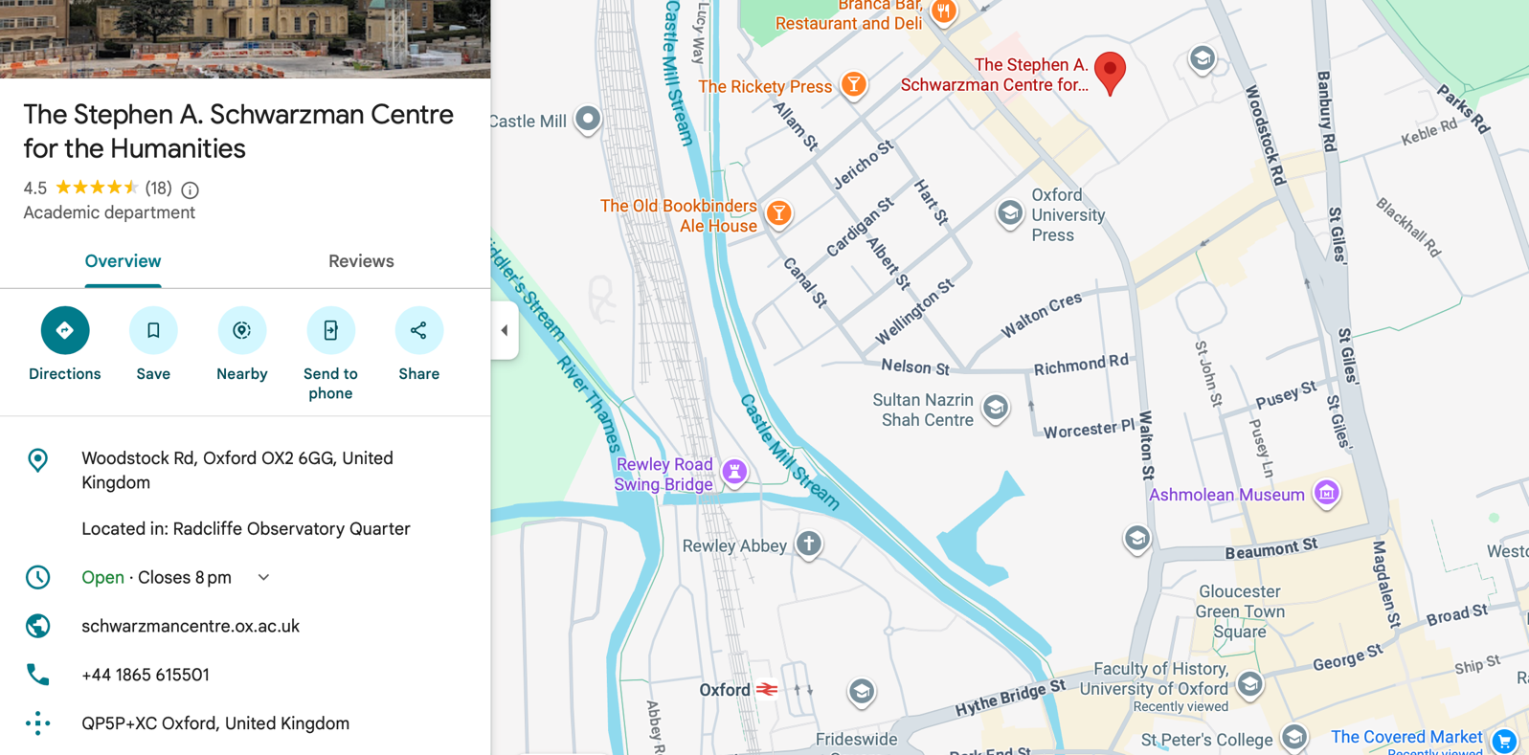
The conference will take place on the ground floor of the building, and is fully accessible, including with accessible and gender-neutral toilets. Panels will take place in Seminar Room 63 and the Learning Centre. There are five minutes between each panel to allow attendees to swap room. Lunch and refreshments will be served in Room 79A and can be eaten in the Great Hall or outside spaces.
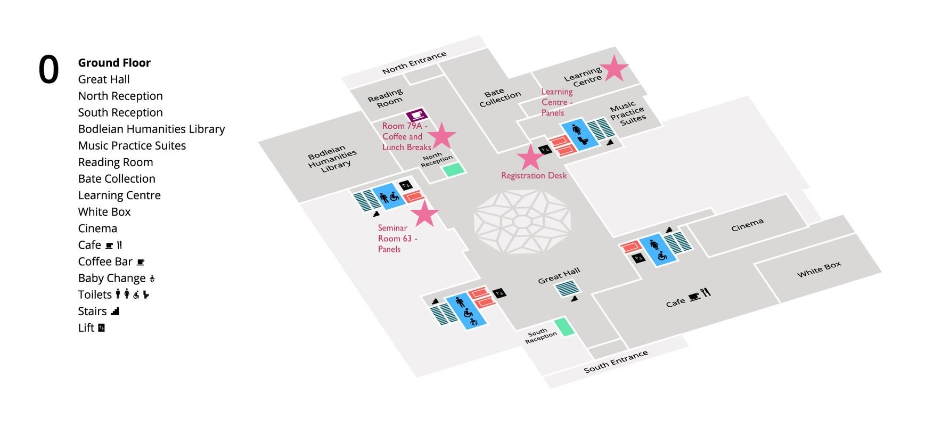
Registration
Registration will take place on the day between 8.30-9.00am. Please collect your printed copy of this conference pack and your name badge from the registration desk opposite the Learning Centre, at the North Entrance.
If you are unable to arrive this early due to travel constraints, please let us know as soon as possible. If travel difficulties arise on the day and you’re running late, you can contact us by email.
Travelling to and Staying in Oxford
Unfortunately we cannot provide any help or funding for travel and accommodation. The venue is approximately a 20 minute walk, 15 minute bus ride, or 7 minute cab from Oxford Railway Station, and a 10 minute walk or bus ride, or 5 minute cab from Gloucester Green Bus Station. There are many places to stay in Oxford, with affordable options including Premier Inn and Marriott in central Oxford, and easyHotel in Summertown, north of the venue.
Eating and Drinking
A sandwich lunch from a local cafe and a morning coffee and refreshments break will be provided. Dietary requirements will be catered for. The Schwarzman Centre’s Café and Coffee Bar are open weekdays 08:00 – 16:00.
Conference drinks will take place at a nearby pub following the end of proceedings. Full details will be announced on the day.
The Schwarzman Centre is in Oxford’s pretty Jericho area, and there are many options for breakfast and dinner nearby. A few recommendations are Edge Coffee, Opera Café, Common Ground Coffee, Taylors Sandwiches, Manos Greek Food Bar, The Victoria Pub, Pierre Victoire, and Mamma Mia Pizzeria. Or you can walk 15 minutes to explore the centre of Oxford!

